TRACE TABLE

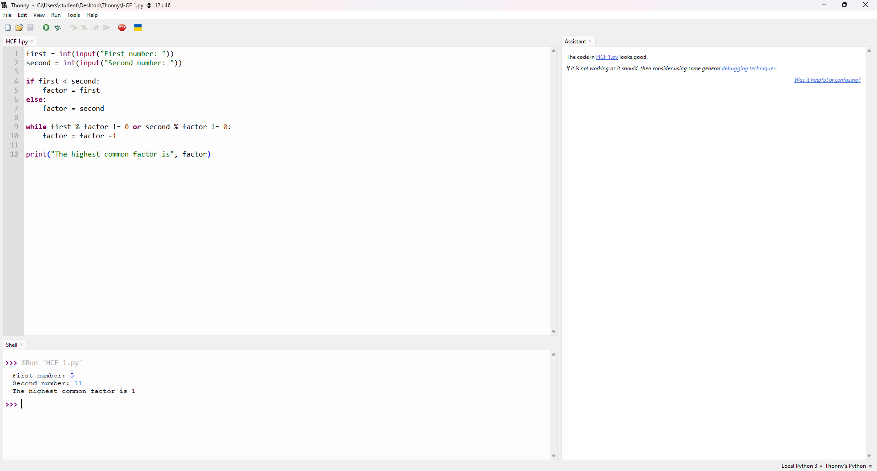
TRACE TABLE for the test data
Test Case | First | Second | Expected result
1 | 9 | 15 | 3
2 | 5 | 11 | 1 (no common factor except 1)
3 | 5 | 5 | 5 (a number and itself)

